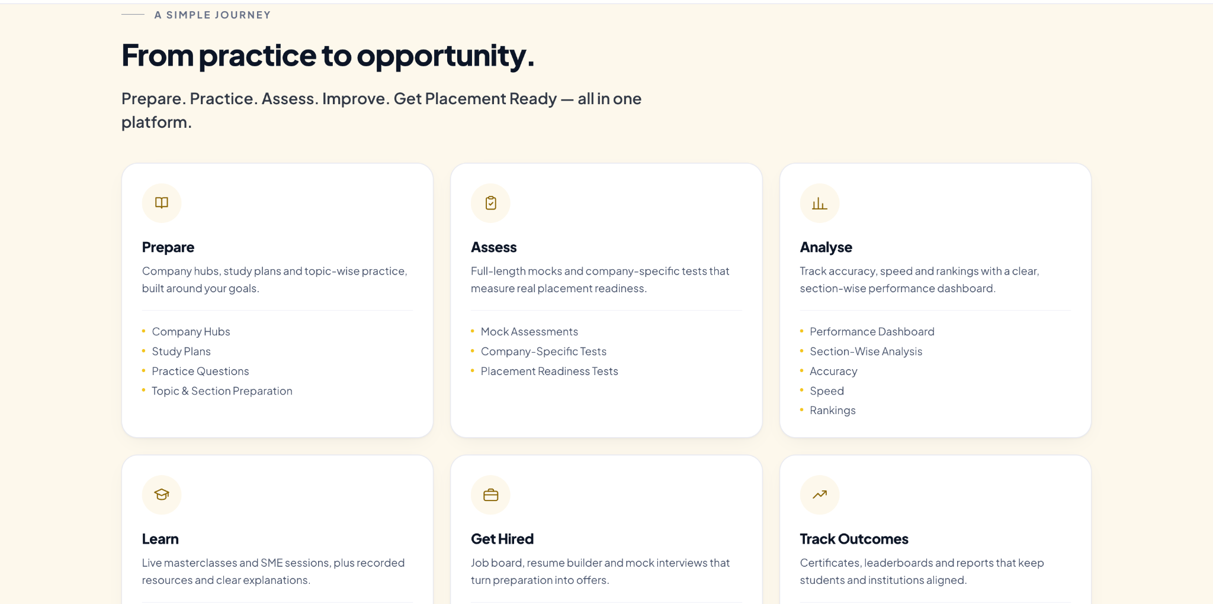

- Make This Section More Visually Engaging
  - The current 6-card layout is functional, but it still feels a bit plain.
  - Please make the overall section more premium and visually attractive.
  - The cards should feel more polished, engaging and easier to scan at first glance.
- Enhance All Cards
  - Improve the visual treatment of all cards using:
    - Better icon usage
    - Stronger hierarchy
    - Cleaner spacing and padding
    - More attractive dividers/content grouping
    - Subtle hover interactions
  - The cards should look richer without becoming cluttered.
- Add More Icons / Visual Cues
  - You can add more small supporting icons or visual cues inside the cards where relevant.
  - For example:
    - One main icon for the pillar
    - Small icons or styled bullets for feature points
  - This will make the cards feel more dynamic and less text-heavy.
- Add Eyebrow Texts
  - Please add small eyebrow/label text above each main card title to improve hierarchy.
  - Example direction:
    - Simple Journey on prephasz
    - Step 01
    - Feature Pillar
    - Placement Preparation
  - Keep these small, clean and consistent across all cards.
- Update the Section Label
  - Instead of “A Simple Journey”, please change it to:
- “Simple Journey on prephasz”
  - This will make the section more contextual and directly connected to the platform.
- Keep the Section Visually Balanced
  - While improving the cards, please maintain:
    - Equal card heights
    - Consistent spacing between cards
    - Uniform icon treatment
    - Uniform eyebrow text styling
    - Consistent internal alignment
  - The final section should feel more premium, structured and visually appealing.

